CSCE 623 Project Proposal

Rain Dartt

23 April 2021

The motivation behind the thesis topic sponsored by AFPC is to review resumes for technical positions using NLP techniques and determine if the specialized experience responses from applicants meet job posting requirements. This is a classification problem with two potential classes: meeting or not meeting the requirements. Currently, AFPC relies on human technicians who are not trained or familiar with field-specific jargon that often appears in these resumes, so misclassification is too common, resulting in time wasted on false positives and accusations of unfairness (and worse) from false negatives. While this thesis focuses only on the specialized experience open response text field, AFPC is investigating the process as a whole to find opportunities for increased accuracy or timeliness through automation.

Figure 1 below demonstrates the data science trajectory of the thesis (DSTs are described in Martinez-Plumed et al., 2019). While this project proposal focuses on the Modeling and Result Exploration phases, a brief introduction is helpful for understanding the context. Since AFPC is not able to provide a set of example resumes and true labels, the first step was exploring available data sets for compatibility. The available data that best fits the purpose of the thesis is a recently published corpus of legal contracts. According to the authors, “The dataset includes more than 500 contracts and more than 13,000 expert annotations that span 41 label categories” (Hendrycks et al., 2021, p. 2). The reason the number of annotations is not equal to the product of contracts and label categories is that not every contract includes an entry for every label. The master clauses csv file (manually curated by experts) contains a row for each contract and two columns for each label category: the first instance contains the phrase or clause that meets that label while the second condenses and standardizes it into a format that makes it easier to present. The existence of any non-blank data demonstrates that the category did apply to the contract in question.

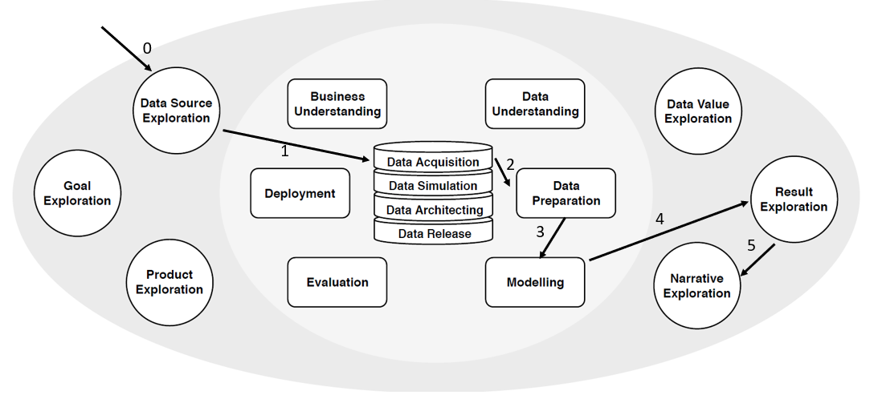

Figure 1. Thesis Data Science Trajectory

Rather than asking “does this resume contain clauses that fulfill each of the specialized experience requirements?”, this data set can be used to ask the similarly-formed question of “does this contract contain clauses that meet each of the label categories requested?” The obvious shortfall in the analogy (besides the aforementioned dearth of truth data to train a model) is that job posting likely contain more than 41 unique experience requirements across the domain, and each requirement would be represented less often. This may be addressed by shrinking the domain and training separate models on their own industry specialties; regardless, that is a problem for another time.

Instead of going back to the contracts themselves to extract clauses that fit into categories using a model like the ones in the article (a task more suited to the NLP class or thesis as a whole), the target of this project is to use a classifier model that uses knowledge about the values of a subset of label categories to predict which other categories are likely to be present. Some labels categories are present in nearly every contract while others are rarely represented, so the most interesting information is likely which rare categories co-occur frequently. The model predictions can be compared against the results from the master clauses CSV with measures such as accuracy, precision, recall, and F1 score.

This project fits into the overall thesis efforts by affecting the narrative exploration part where the results are displayed to hiring staff. For example, if the model is 95% confident that the applicant meets specialized experience requirement #1 (and displays the portion of the resume that most closely matches the requirement) but only 40% confident about fulfilling requirement #2, a special note could accompany the closest match that says something to the effect of “72% of applicants who met requirement #1 with >90% confidence also met requirement #2, so it is possible this applicant possesses the skills but did not include it in a way detectable by this model.”

Bibliography

Hendrycks, D., Burns, C., Chen, A., & Ball, S. (2021). *CUAD: An Expert-Annotated NLP Dataset for Legal Contract Review*. [http://arxiv.org/abs/2103.06268](http://arxiv.org/abs/2103.06268%20)

Martinez-Plumed, F., Contreras-Ochando, L., Ferri, C., Hernandez Orallo, J., Kull, M., Lachiche, N., Ramirez Quintana, M. J., & Flach, P. A. (2019). CRISP-DM Twenty Years Later: From Data Mining Processes to Data Science Trajectories. *IEEE Transactions on Knowledge and Data Engineering*, 1–1. <https://doi.org/10.1109/tkde.2019.2962680>

Appendix A.

Master Clauses CSV

